Atitit oppo sms bek on u55

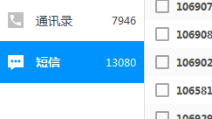

360手机助手导出的短信oppo on u55

File size 3m 1.3w sms